Epic Pseudonatural

Overseer

**Gargantuan Outsider**

**Hit Dice:** 40d8+600 (920 hp)

**Initiative:** +9

**Speed:** 60 ft. (12 square)

**Armor Class:** 43 (–3 size, +5 Dex, +6 fungus armor, +35 natural), touch 12, flat-footed 38

**Base Attack/Grapple:** +30/+67

**Attack:** Eye rays +30 ranged touch and tentacle rakes +40 melee (2d8+12 [20])

**Full Attack:** Eye rays +30 ranged touch and 18 tentacle rakes +40 melee (2d8+12 [20]) and 3 bites +40 melee (3d6+10 [20])

**Space/Reach:** 20 ft./20 ft.

**Special Attacks:** *Command beholder,* constrict 2d6+14 [20], eye rays, improved grab

**Special Qualities:** All-around vision, darkvision 60 ft., fungus, spell resistance 35, electricity and acid resistance 60, DR 20/+7

**Saves:** Fort +32, Ref +18, Will +35

**Abilities:** Str 60, Dex 21, Con 40, Int 20, Wis 28, Cha 22

**Skills:** Knowledge (any four) +22, Listen +21, Search +22, Spot +21, Survival +4 (+6 following tracks)

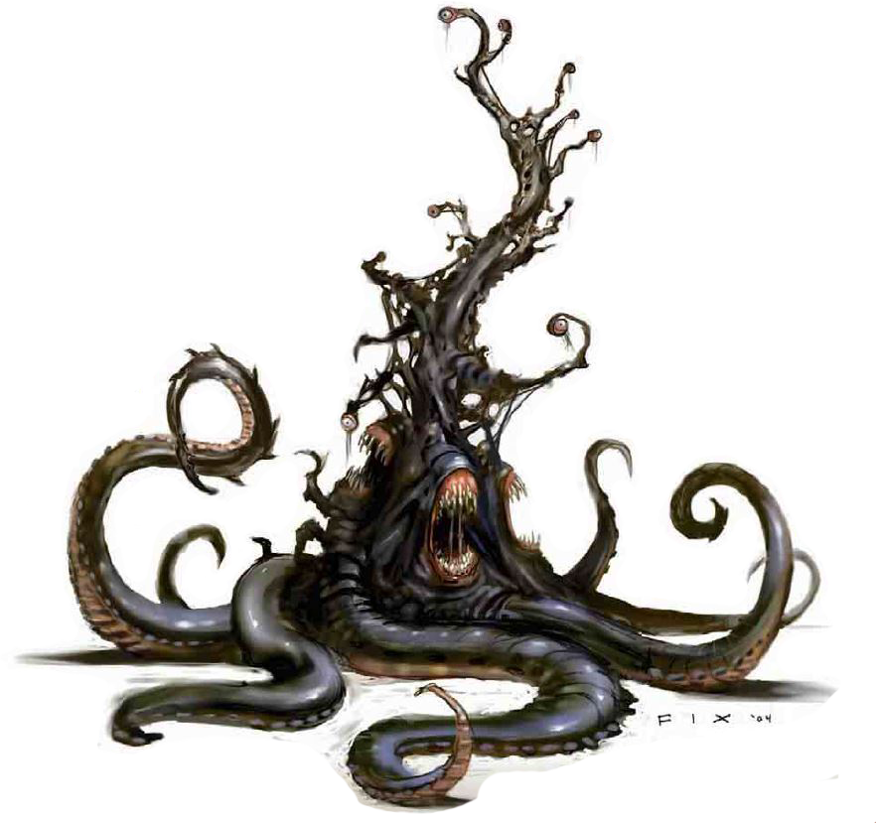**Feats:** Alertness, Enlarge Spell, Great Fortitude, Improved Initiative, Metaray†, Maximize Spell, Epic fortitude, Enhance Spell, Epic speed, Epic Will.

† New feat described on page 45.

**Environment:** Cold hills

**Alignment**: Always lawful evil

**Challenge Rating:** 50

*This creature resembles a black, rubbery tree of undulant flesh. Thick, matted sheets of wiry fungus grow all over its surface. The tree’s thirteen gnarled branches each end in a single large eye. Three fanged maws gurgle lower on the tree’s trunk, and it supports itself with a thick, coiling mass of eight long tentacles.*

Overseers serve hive mothers as subordinates in large beholder communities, similar to the way humanoid rulers employ others as guards or governors. The rare overseer that does not belong to a beholder community seeks out societies of other creatures to infiltrate and dominate from behind the scenes. An overseer is uncomfortable without a large number of subservient minions to tend to its real (or imagined) needs. An overseer is normally about 15 feet tall and weighs 4,000 pounds. They speak Beholder and Common.

Combat

Unlike most other beholderkin, overseers have a large number of physical attacks that they can use in melee combat to great effect. Nevertheless, they prefer to let their minions handle such crude activities as melee combat and concentrate on using their eye rays against enemies. An overseer’s greatest weakness is its lack of mobility; when faced with a foe that uses greater mobility to stay out of range of its eye rays, an overseer typically retreats to plot revenge on its own terms. Most overseers keep at least one magic item that allows some form of teleportation handy for just such an event.

**Command Beholder (Sp):** An overseer can use *dominate monster* at will as a spell-like ability (caster level 14th), but onlyagainst beholders and beholderkin (except for hive mothersand other overseers). A beholder can resist this effect with aDC 36 Will saving throw. The save DC is Charisma-based. Thisis the equivalent of a 9th-level spell.The maximum number of beholders an overseer can commandat one time equals its Hit Dice plus its Charisma modifier.Thus, the average overseer can command up to 20 beholdersor beholderkin at a time.If an overseer loses control of a *dominated* beholder (as isthe case if a *dominated* beholder is in the antimagic cone ofanother beholder), the overseer can immediately sense the lossof control and knows the position and distance to the beholderat the time control was lost. If control does not return within a few rounds, the overseer seeks out the rogue beholder to investigate and possibly punish it.

**Constrict (Ex):** An overseer deals 2d6+6 points of damage with a successful grapple check.

**Rotting Constriction (Ex):** Once the creature has hold of an opponent, each successful grapple check it makes during subsequent rounds permanently drains 2d4 points of Constitution. At the same time, the creature regains 10 lost hit points.

**Eye Rays (Su):** Each of a director’s thirteen small eyes can produce a magical ray once per round as a free action (except for its major creation eye ray; see below). An overseer’s long branches allow it to aim up to five eye rays at targets in any given 90-degree arc. It typically attacks with only four rays in any round, leaving it with the option to use its reactive spell turning or reactive spell immunity eye ray as needed. Each ray has a range of 180 feet, a save DC of 36, and a caster level of 40th. The save DCs are Charsma-based. The thirteen eye rays include:

*Chain Lightning*: This works like the spell, except that if the eye ray misses the initial target, the effect is wasted. Only if the initial target is hit does the lightning arc to other targets.

*Crushing Despair*: This works like the spell, except that it affects only a single target (Will save negates).

*Dominate Person*: The target must succeed on a Will save or be affected as though by the spell.

*Greater Dispel Magic*: This works like the spell, except that an overseer cannot perform an area dispel. If it wishes, it can prepare an action to use this eye to perform a counterspell, but if it does so, it must successfully hit the spellcaster in question.

*Hold Monster*: This works like the spell (Will negates).

*Major Creation*: An overseer uses this eye ray to create miscellaneous gear and equipment for itself or its minions (as the spell) as it deems necessary. It has no offensive function. This eye ray requires a full-round action to use.

*Polar Ray*: The target takes 25d6 points of cold damage.

*Reactive Spell Immunity*: Once per round, this eye can be used to negate a single spell that affects the overseer as the spell is being cast. The overseer must successfully hit the creature that cast the spell in question; if successful, it is immune to that casting of that particular spell. If the spell affects multiple targets or an area, it affects any other targets or the area normally, but the overseer remains immune to its effect. An overseer cannot use this eye ray if it is considered flat-footed against the source of the spell.

*Reactive Spell Turning*: Once per round, this eye can be used to reflect a single-target spell that targets the overseer back to its source as an eye ray. The overseer must hit the source with the eye ray; otherwise, the reflected spell dissipates harmlessly. An overseer cannot use this eye ray if it is considered flat-footed against the source of the spell.

*Stunning*: The target must succeed on a Fortitude save or be stunned for 1d4 rounds.

*Suggestion*: The target must succeed on a Will save or be affected as though by the spell.

*Telekinesis*: An overseer can move objects or creatures that weigh up to 350 pounds, as though with a *telekinesis* spell. Creatures can resist the effect with a successful Will save.

*Temporal Stasis*: The target must succeed on a Fortitude save or be affected as though by the spell.

**Improved Grab (Ex):** To use this ability, an overseer must hit with its bite attack. It can then attempt to start a grapple as a free action without provoking attacks of opportunity. If it wins the grapple check, it establishes a hold and can constrict.

**Fungus (Ex):** An overseer’s protective layer of thick, wiry fungus provides a +6 armor bonus to its Armor Class. This fungus doesn’t impede or restrict the overseer’s movement in any way. The fungus reacts to the overseer’s moods, and changes color as the beholderkin’s emotions change.

**Constant Insight (Su):** The creature makes all its attacks with a +15 insight bonus. The creature is not affected by the miss chance that applies to attacks against a concealed target.

**Spell-Like Abilities:** At will—blur, dimension door, shield, unhallow. Caster level 20th.

**Alternate Form (Su):** At will, a pseudonatural creature can take the form of a grotesque, tentacled mass (or another appropriately gruesome form determined by the DM), but all its abilities remain unchanged despite the alien appearance. Changing shape is a standard action. Other creatures receive a –1 morale penalty on their attack rolls against pseudonatural creatures in this alternate form.